**Screenshots**

1. 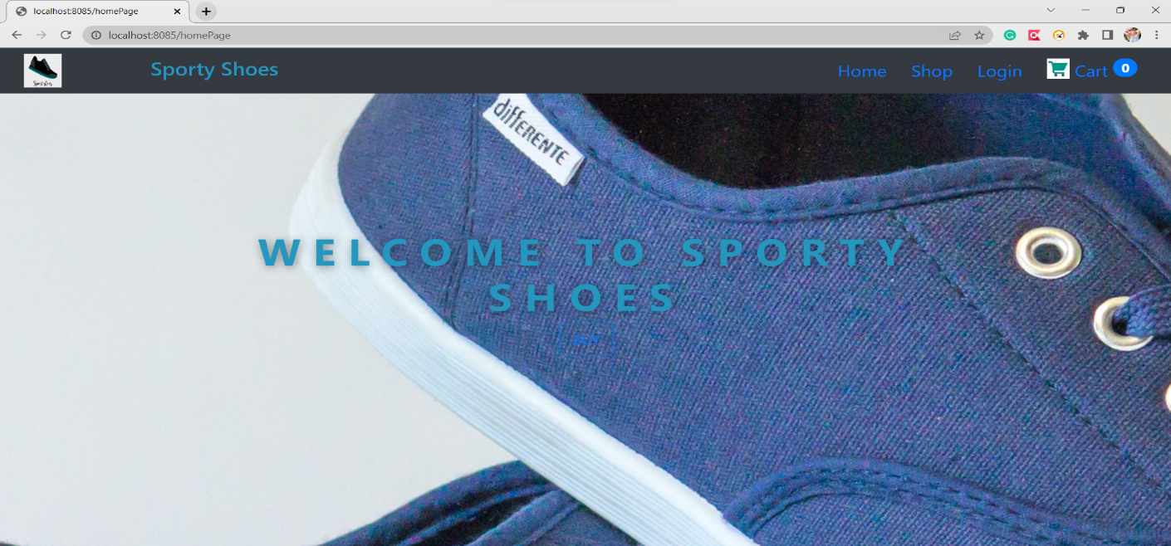Home Page:
2. Shop page:

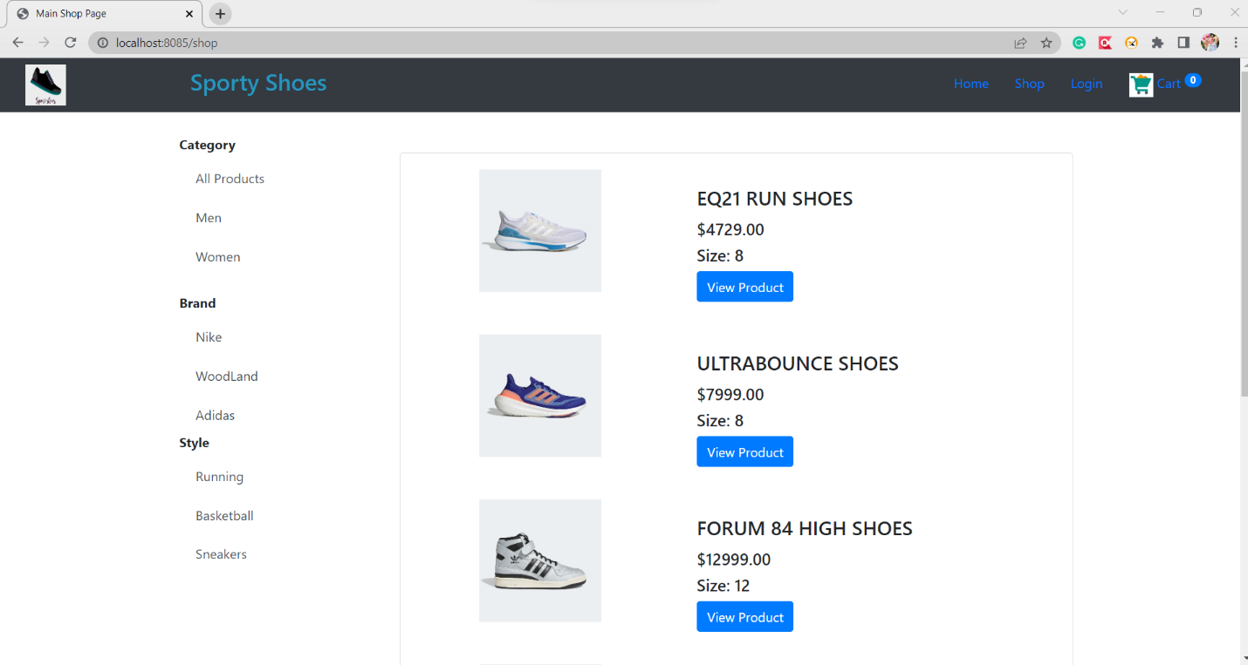

1. By selecting Category Style- as Sneakers

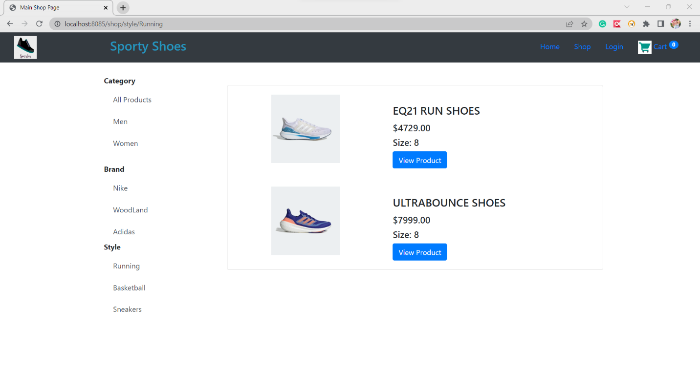

1. View Product Page

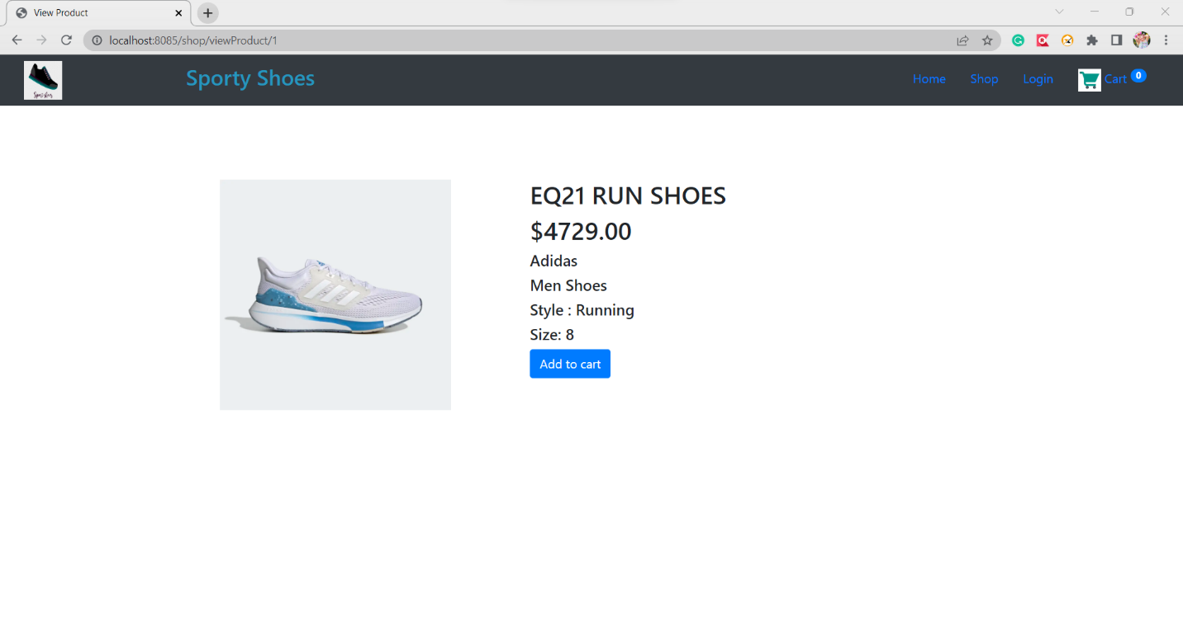

1. Cart Page

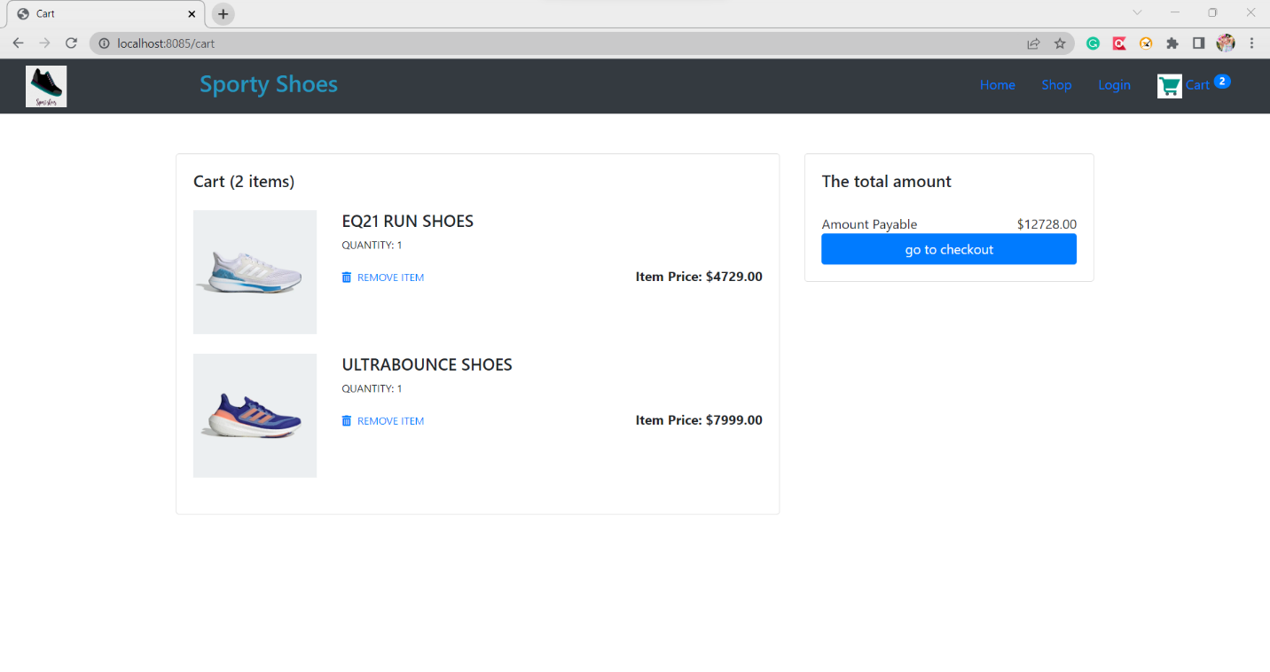

1. After Removing product from cart

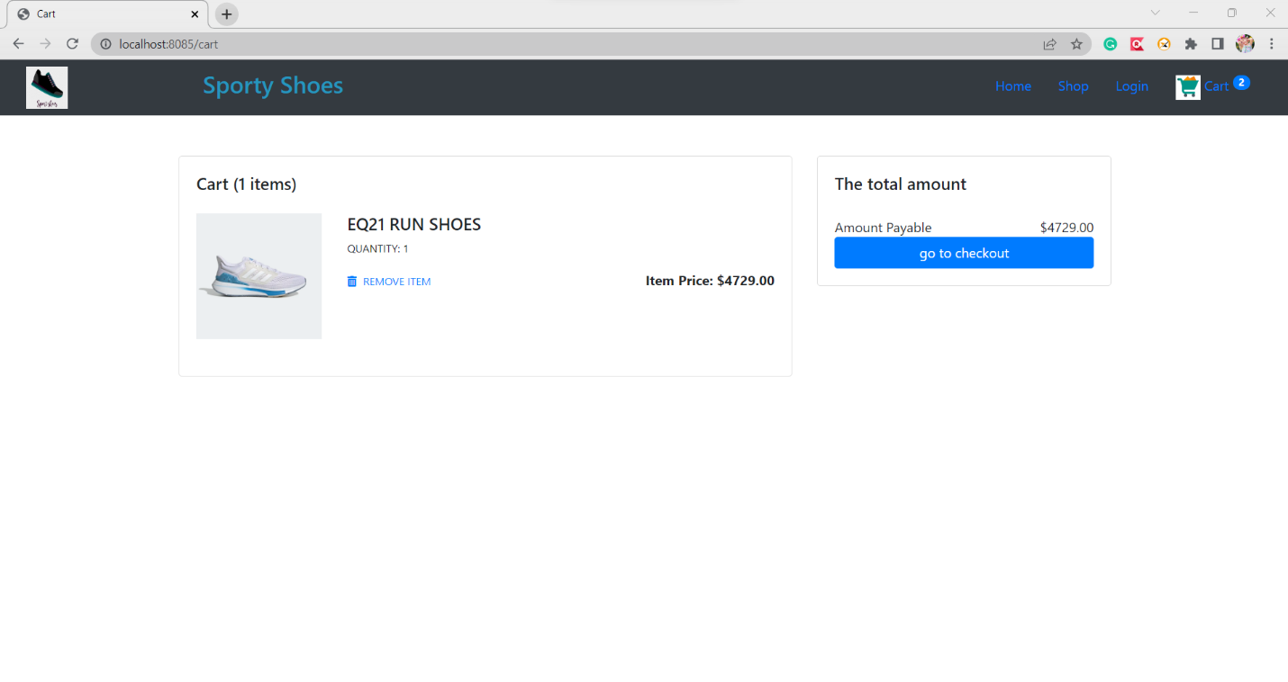

1. Go to checkout without Login

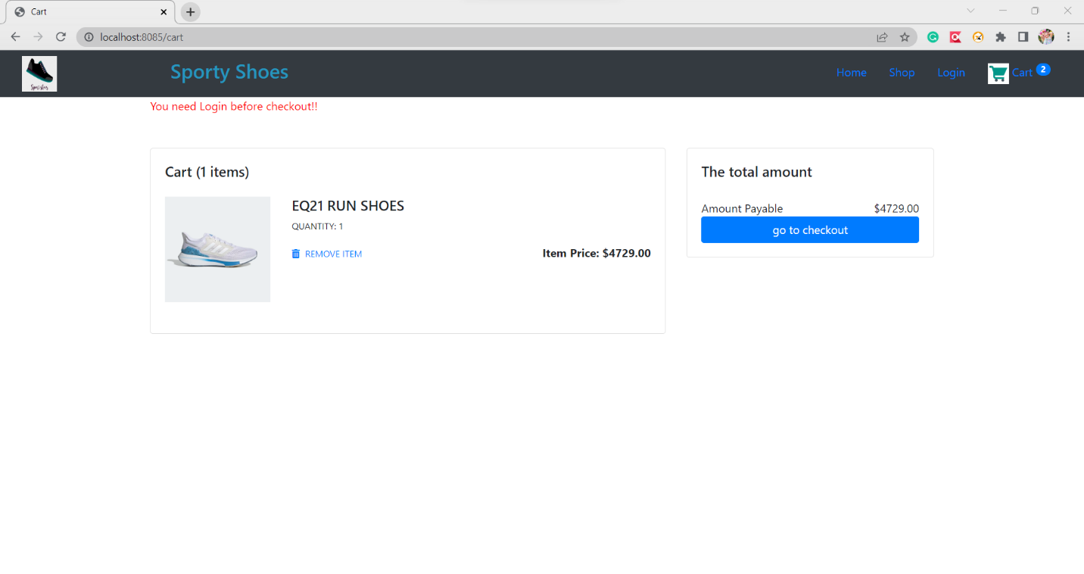

1. User Login Page

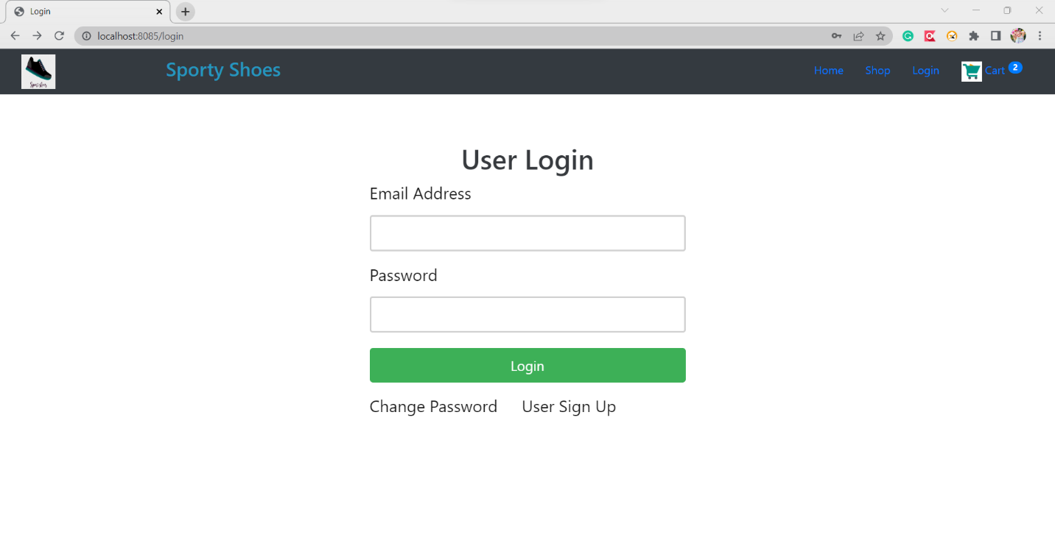

1. User Signup Page

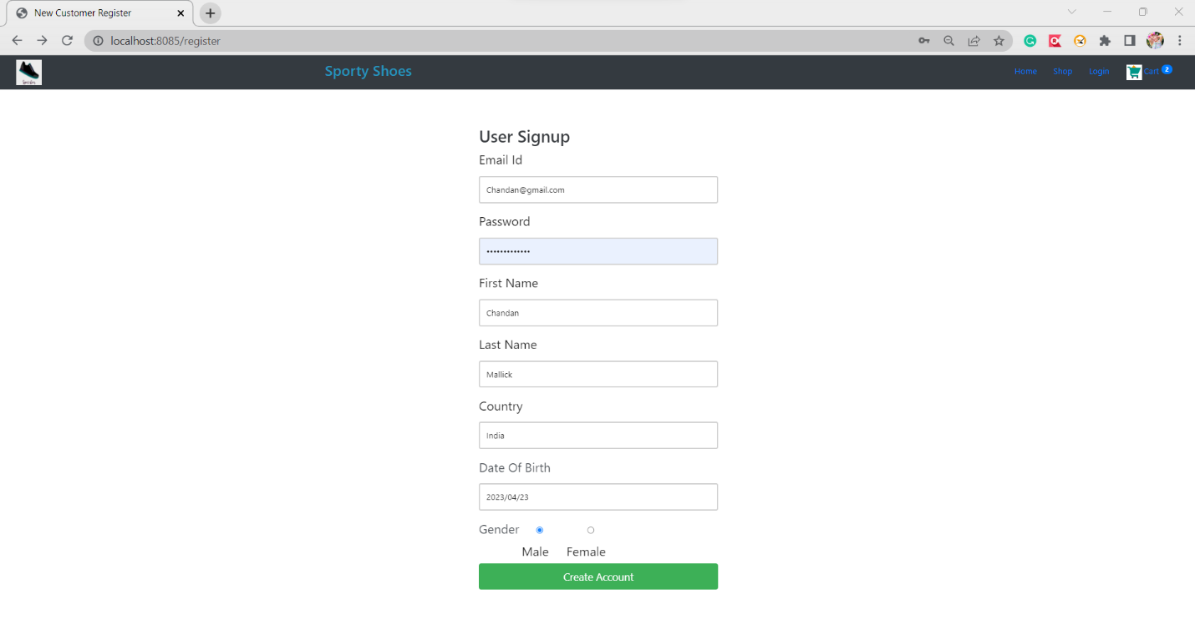

1. Change Password

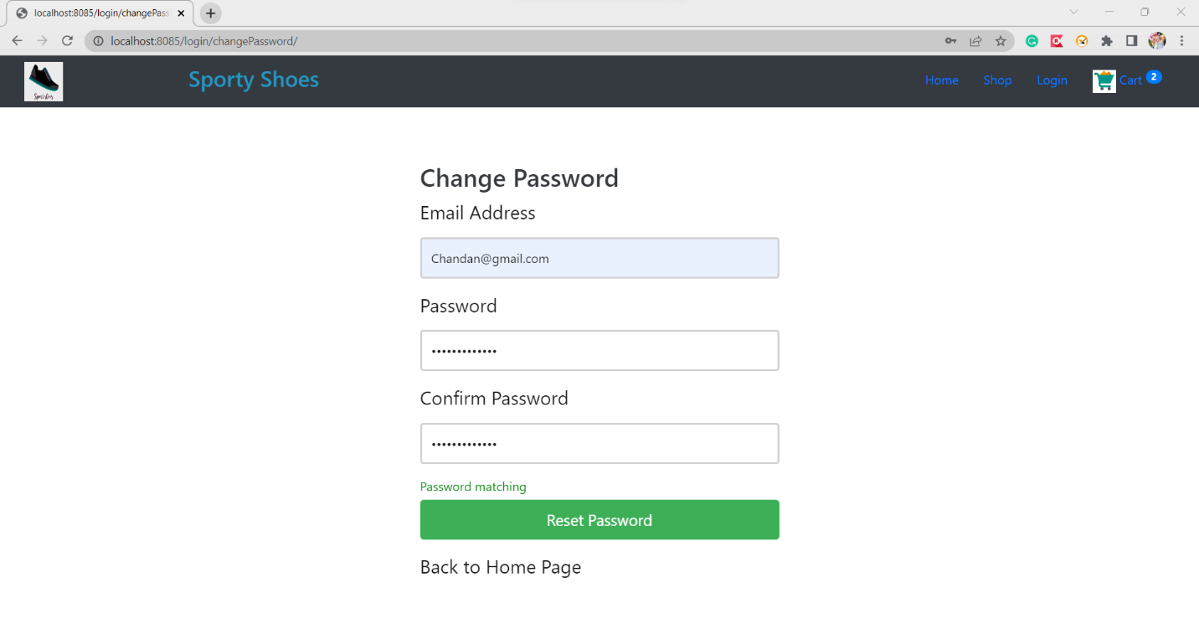

1. After Login Home Page

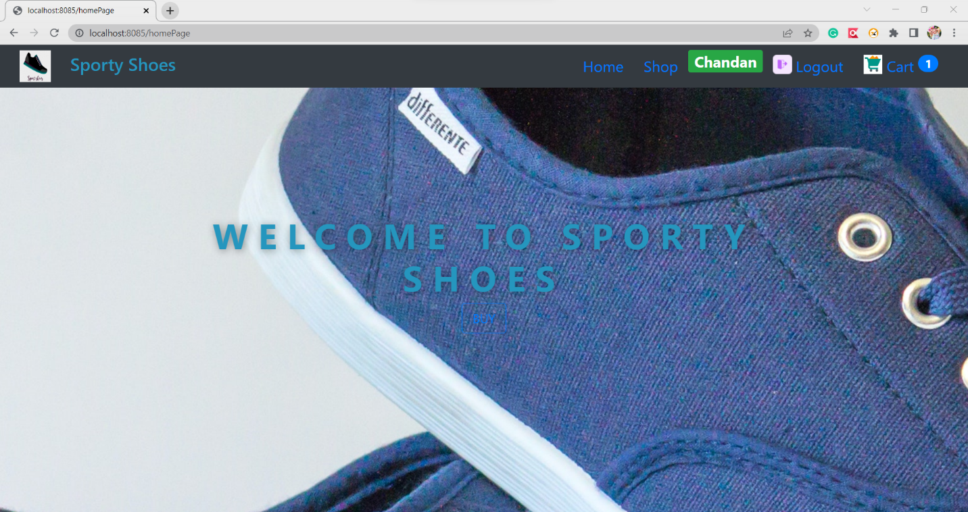

1. Checkout Page

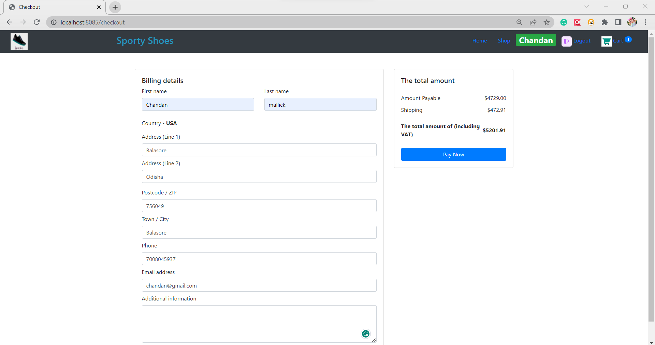

1. Order Confirmed Page

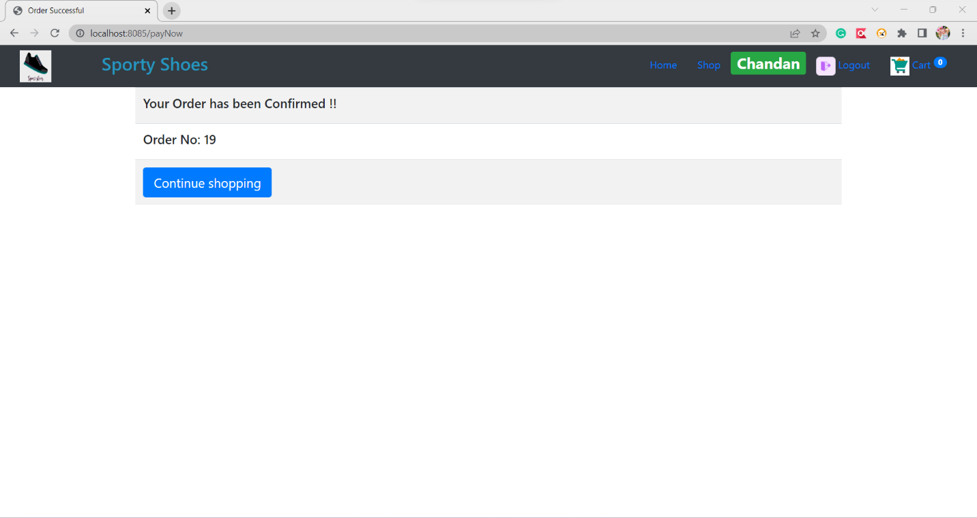

1. Admin Login Page

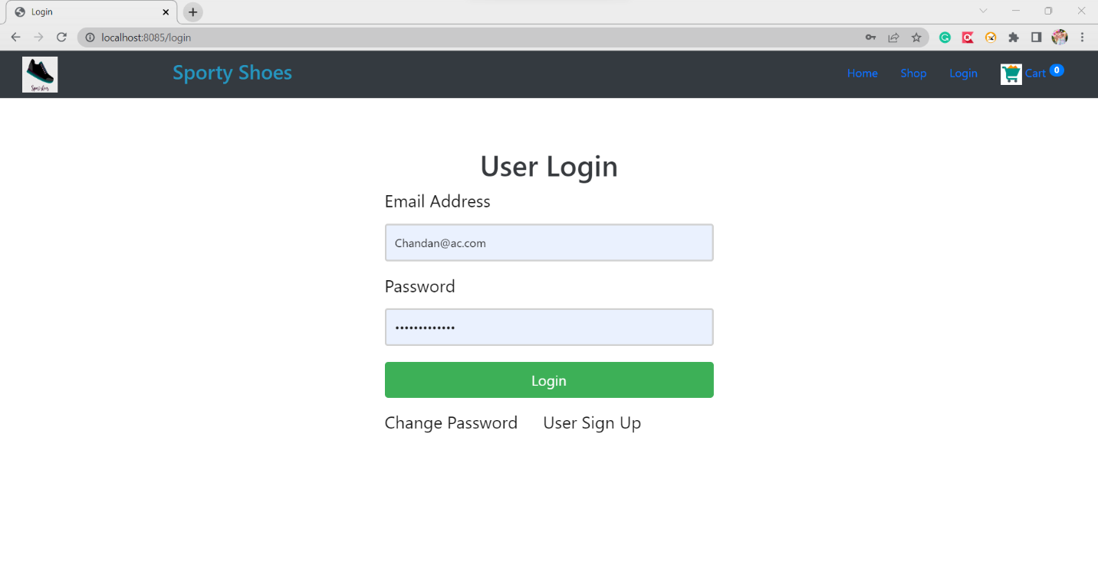

1. Admin Home Page

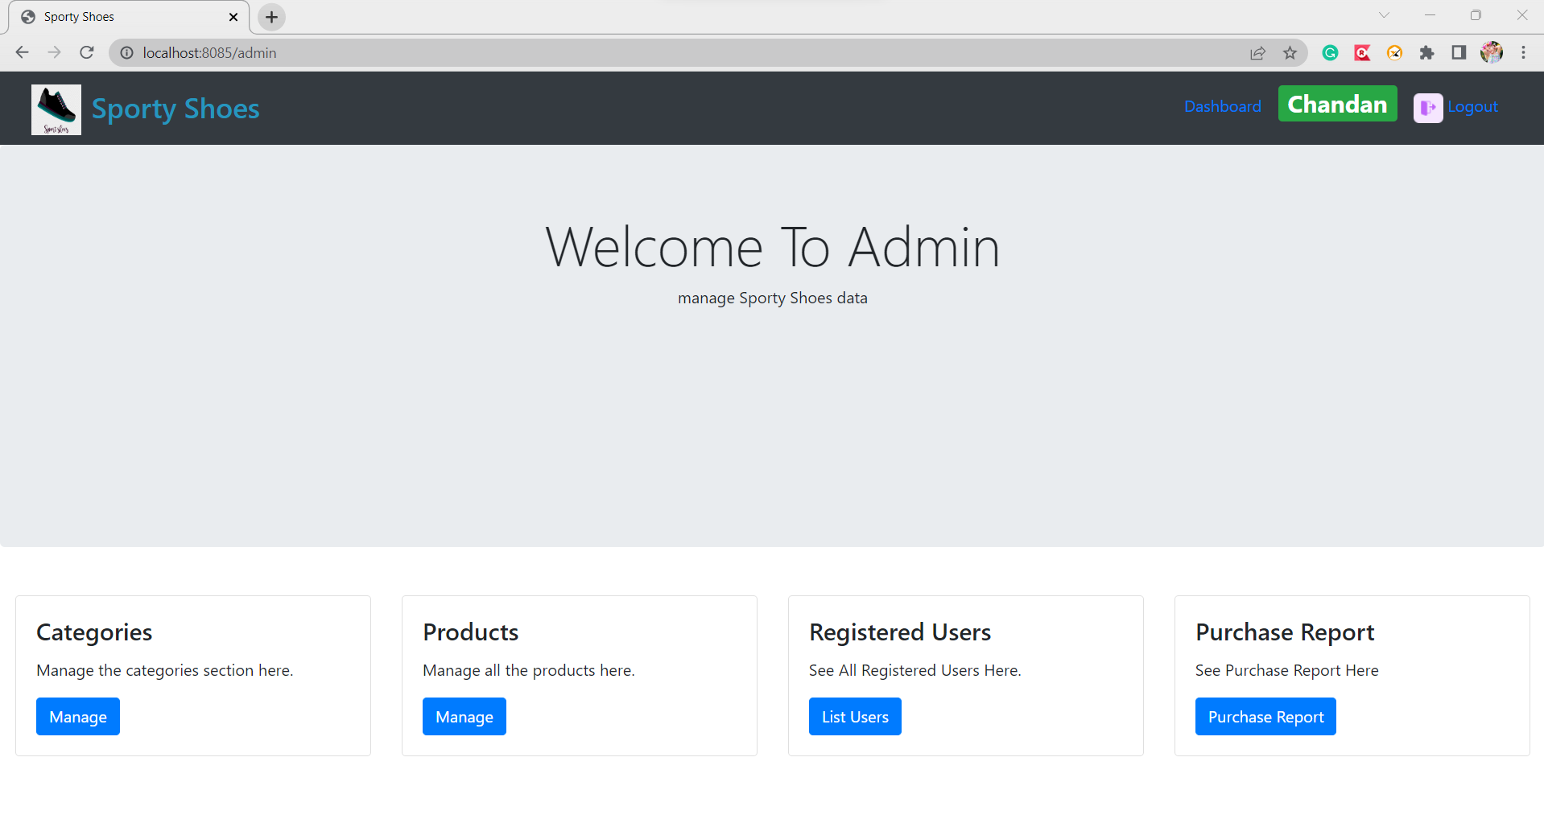

1. Categories List Page

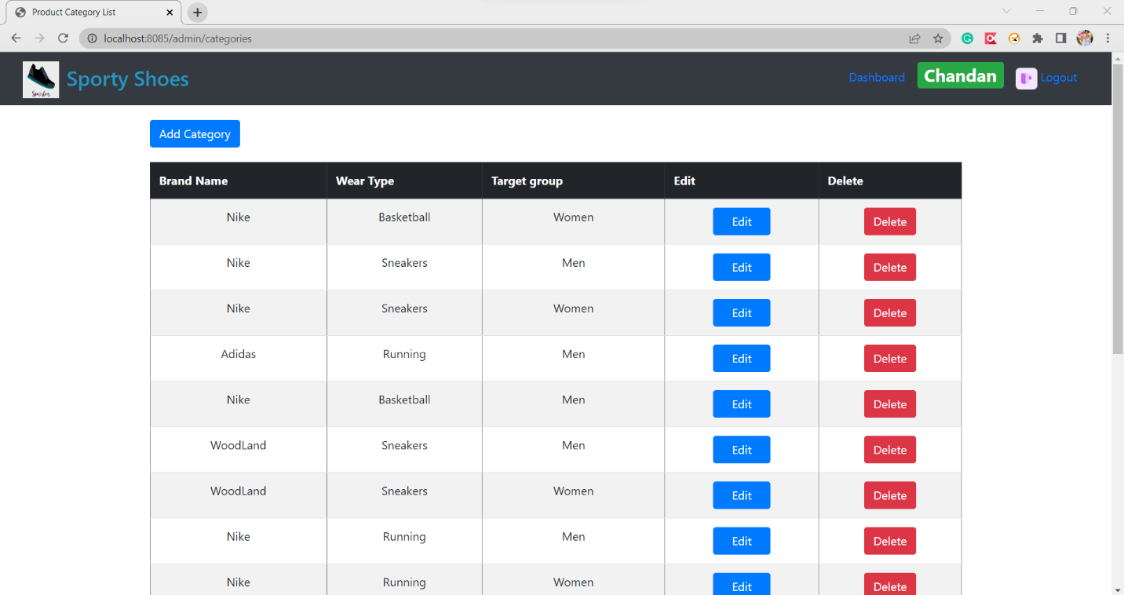

1. Add Categories Page

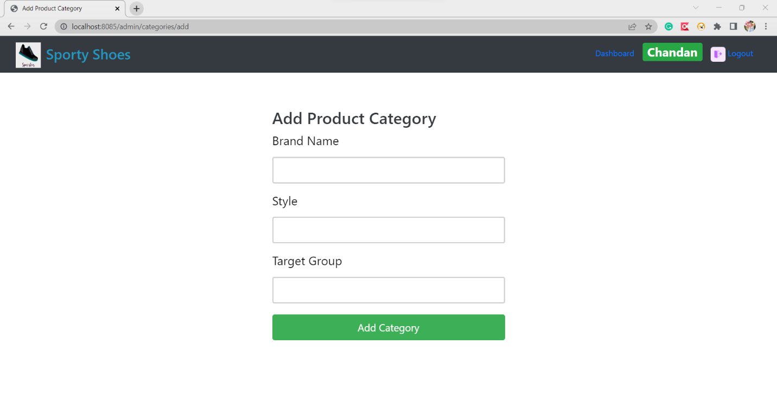

1. Product List Page

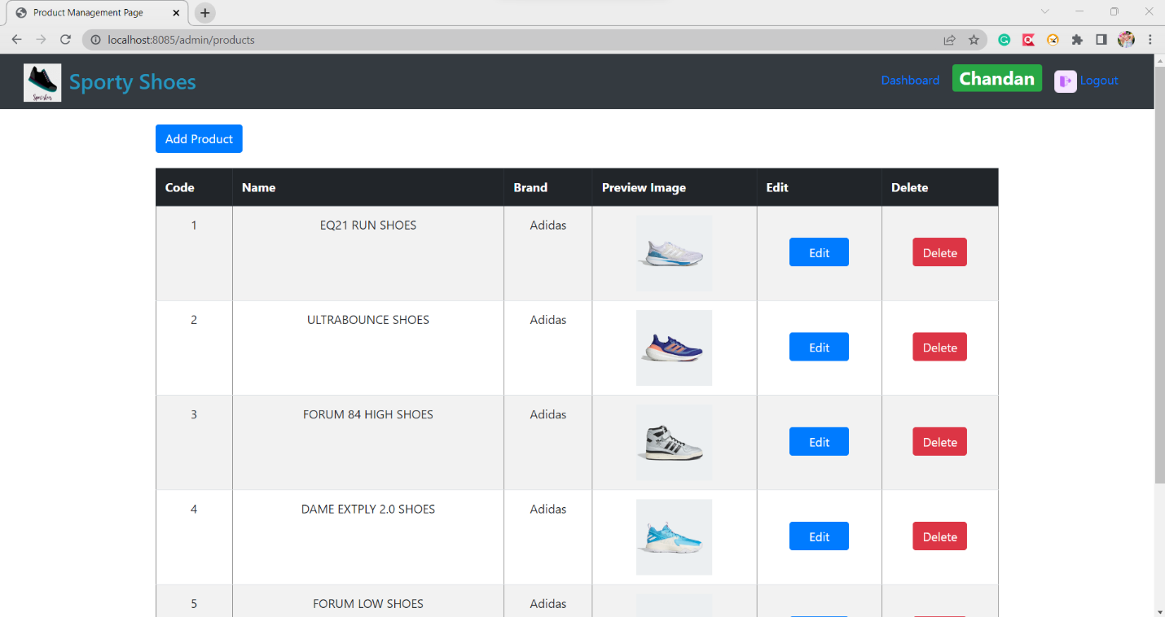

1. Add Product Page

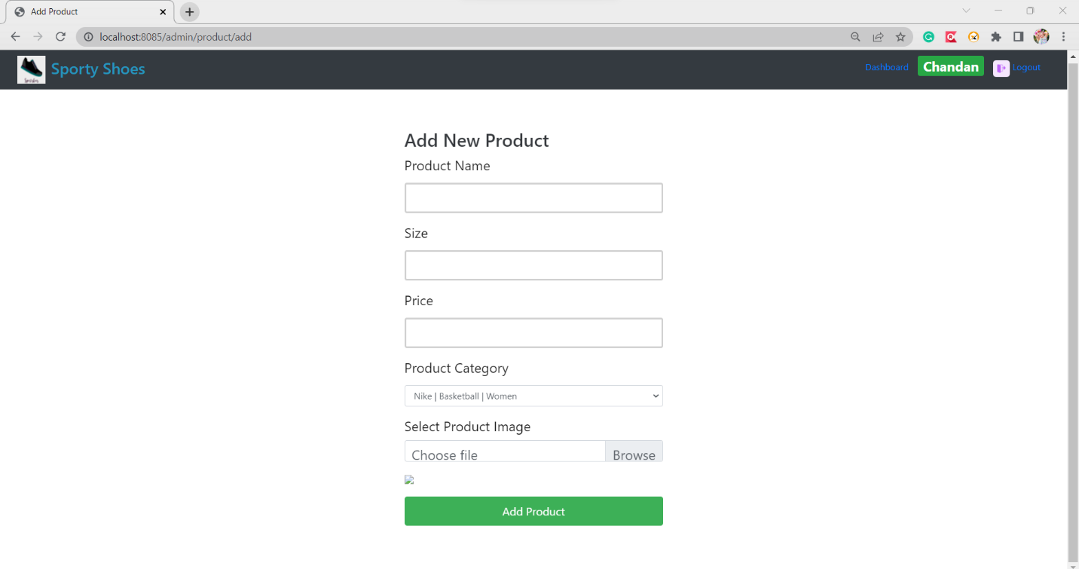

1. Resistered User List

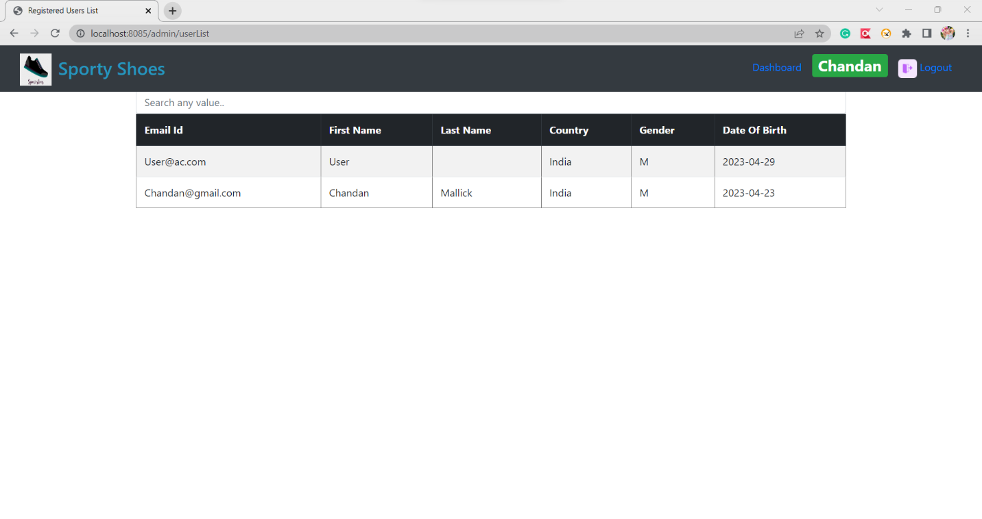

1. Purchage Report Page

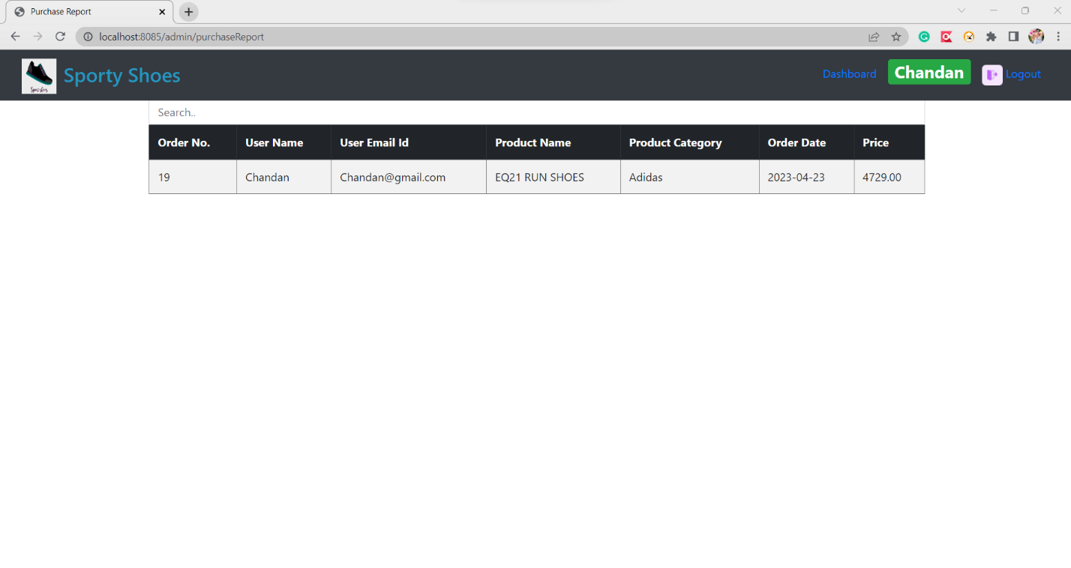

*******************************END********************************************